2. Run a LASSO version of logistic regression, using CV to estimate optimal shrinkage

in the logistic regression parameters using minimum CV-error.

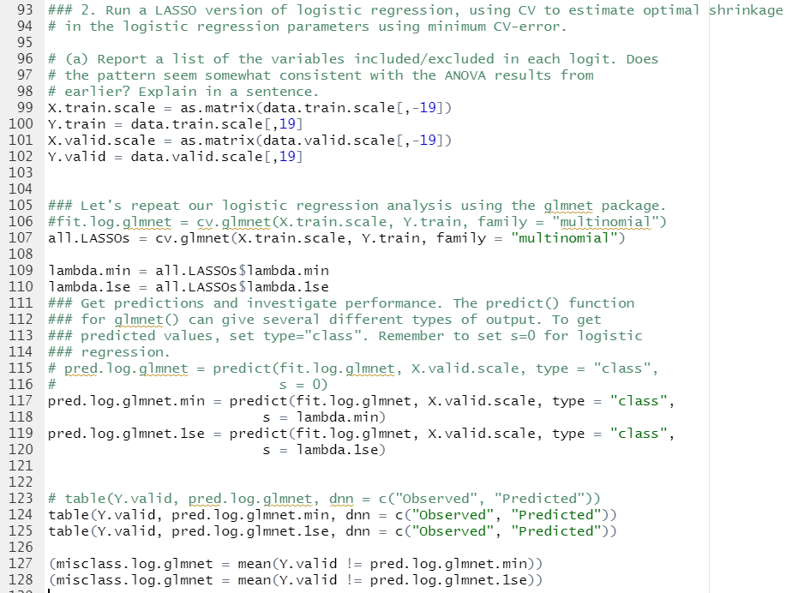



(a) **Report a list of the variables included/excluded in each logit. Does**

**the pattern seem somewhat consistent with the ANOVA results from**

**earlier? Explain in a sentence.**

>lasso.min.coef

(Intercept) 10.47789955

Compactness -6.43735489

Circularity 4.33621387

Distance.Circularity -0.28083026

Radius.Ratio 18.69867552

Pr.Axis.Aspect.Ratio -28.96879784

Max.Length.Aspect.Ratio -4.05453435

Scatter.Ratio 0.05192484

Elongatedness 3.17196076

Pr.Axis.Rectangularity .

Max.Length.Rectangularity -7.57664804

Scaled.Variance.Along.Major.Axis -1.51693002

Scaled.Variance.Along.Minor.Axis 15.67578846

Scaled.Radius.of.Gyration -3.10578781

Skewness.About.Major.Axis -14.41921897

Skewness.About.Minor.Axis 0.04195768

Kurtosis.About.Minor.Axis 0.20849110

Kurtosis.About.Major.Axis 1.07739497

Hollows.Ratio -5.46839934

$`4D`

19 x 1 sparse Matrix of class "dgCMatrix"

1

(Intercept) 13.5155248

Compactness 4.5758051

Circularity -12.3226861

Distance.Circularity 0.2808303

Radius.Ratio 21.2169082

Pr.Axis.Aspect.Ratio -28.5843066

Max.Length.Aspect.Ratio -10.0694529

Scatter.Ratio .

Elongatedness -3.1719608

Pr.Axis.Rectangularity 8.0309236

Max.Length.Rectangularity -0.8662893

Scaled.Variance.Along.Major.Axis .

Scaled.Variance.Along.Minor.Axis -10.6377616

Scaled.Radius.of.Gyration 6.2865542

Skewness.About.Major.Axis -10.7250672

Skewness.About.Minor.Axis 0.1011371

Kurtosis.About.Minor.Axis -0.2084911

Kurtosis.About.Major.Axis -12.7160699

Hollows.Ratio 5.4683993

$BUS

19 x 1 sparse Matrix of class "dgCMatrix"

1

(Intercept) 0.1965590

Compactness -4.5758051

Circularity .

Distance.Circularity -6.5642736

Radius.Ratio -64.6005083

Pr.Axis.Aspect.Ratio 105.6089591

Max.Length.Aspect.Ratio 4.0545344

Scatter.Ratio .

Elongatedness -19.7803722

Pr.Axis.Rectangularity .

Max.Length.Rectangularity 0.8662893

Scaled.Variance.Along.Major.Axis 46.2307520

Scaled.Variance.Along.Minor.Axis .

Scaled.Radius.of.Gyration 3.1057878

Skewness.About.Major.Axis 10.7250672

Skewness.About.Minor.Axis -5.1044260

Kurtosis.About.Minor.Axis 3.1220789

Kurtosis.About.Major.Axis 47.7261462

Hollows.Ratio -25.2995979

$VAN

19 x 1 sparse Matrix of class "dgCMatrix"

1

(Intercept) -24.18998339

Compactness 12.94557435

Circularity .

Distance.Circularity 21.91993544

Radius.Ratio -18.69867552

Pr.Axis.Aspect.Ratio 28.58430664

Max.Length.Aspect.Ratio 29.33960573

Scatter.Ratio -35.12848043

Elongatedness 9.29536204

Pr.Axis.Rectangularity -19.40725058

Max.Length.Rectangularity 37.68734783

Scaled.Variance.Along.Major.Axis .

Scaled.Variance.Along.Minor.Axis .

Scaled.Radius.of.Gyration -19.04715083

Skewness.About.Major.Axis 35.85145712

Skewness.About.Minor.Axis -0.04195768

Kurtosis.About.Minor.Axis -3.22501509

Kurtosis.About.Major.Axis -1.07739497

Hollows.Ratio 13.67304898

Lasso.1se.coef

(Intercept) 7.49601576

Compactness -6.19399153

Circularity 1.88339320

Distance.Circularity -0.01332511

Radius.Ratio 11.93254099

Pr.Axis.Aspect.Ratio -19.56533341

Max.Length.Aspect.Ratio -0.06776796

Scatter.Ratio .

Elongatedness 1.95032211

Pr.Axis.Rectangularity .

Max.Length.Rectangularity -4.05991526

Scaled.Variance.Along.Major.Axis -0.77740303

Scaled.Variance.Along.Minor.Axis 12.21014816

Scaled.Radius.of.Gyration -2.43221848

Skewness.About.Major.Axis -11.87408238

Skewness.About.Minor.Axis 0.23303965

Kurtosis.About.Minor.Axis 0.09133776

Kurtosis.About.Major.Axis .

Hollows.Ratio -4.22927907

$`4D`

19 x 1 sparse Matrix of class "dgCMatrix"

1

(Intercept) 8.99540239

Compactness 3.44488105

Circularity -11.36835569

Distance.Circularity 0.01332511

Radius.Ratio 14.84922077

Pr.Axis.Aspect.Ratio -20.45341274

Max.Length.Aspect.Ratio -5.35577614

Scatter.Ratio .

Elongatedness -1.95032211

Pr.Axis.Rectangularity 4.10408335

Max.Length.Rectangularity -0.30553560

Scaled.Variance.Along.Major.Axis .

Scaled.Variance.Along.Minor.Axis -4.71025706

Scaled.Radius.of.Gyration 5.98296974

Skewness.About.Major.Axis -9.00831800

Skewness.About.Minor.Axis 0.33918807

Kurtosis.About.Minor.Axis -0.09133776

Kurtosis.About.Major.Axis -10.81017188

Hollows.Ratio 4.22927907

$BUS

19 x 1 sparse Matrix of class "dgCMatrix"

1

(Intercept) 0.73796804

Compactness -3.44488105

Circularity .

Distance.Circularity -3.91462628

Radius.Ratio -45.29986372

Pr.Axis.Aspect.Ratio 73.72073905

Max.Length.Aspect.Ratio 0.06776796

Scatter.Ratio .

Elongatedness -14.95283732

Pr.Axis.Rectangularity .

Max.Length.Rectangularity 0.30553560

Scaled.Variance.Along.Major.Axis 30.29959732

Scaled.Variance.Along.Minor.Axis .

Scaled.Radius.of.Gyration 2.43221848

Skewness.About.Major.Axis 9.00831800

Skewness.About.Minor.Axis -3.78573575

Kurtosis.About.Minor.Axis 1.76934625

Kurtosis.About.Major.Axis 32.16611869

Hollows.Ratio -17.62158854

$VAN

19 x 1 sparse Matrix of class "dgCMatrix"

1

(Intercept) -17.2293862

Compactness 9.3044324

Circularity .

Distance.Circularity 13.1945727

Radius.Ratio -11.9325410

Pr.Axis.Aspect.Ratio 19.5653334

Max.Length.Aspect.Ratio 18.3302287

Scatter.Ratio -23.2613542

Elongatedness 7.8143496

Pr.Axis.Rectangularity -8.5801997

Max.Length.Rectangularity 26.7657963

Scaled.Variance.Along.Major.Axis .

Scaled.Variance.Along.Minor.Axis .

Scaled.Radius.of.Gyration -13.5295229

Skewness.About.Major.Axis 21.9994724

Skewness.About.Minor.Axis -0.2330397

Kurtosis.About.Minor.Axis -2.3249012

Kurtosis.About.Major.Axis .

Hollows.Ratio 7.3440734

The variable with numerical values (not just dot) looks like variables in a list from ANOVA

(b) Compute and **report training and test error**. **How does test error compare**

**to other methods?**

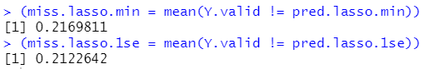

-> The error is lower than other methods.